***Direct control of Single & Double acting Cylinder***

***Objective:***

To study and control single and double acting cylinder using push buttons

***Equipment’s and parts:***

* Single acting cylinder
* Double acting cylinder
* Connecting Pipes
* Mechanical push button
* Fluid (Air) Reservoir
* Regulator
* Air distributer (Multi dia pipes Junction)

***Working Explanation:***

The compressed air goes to switches that are mechanically operated and then goes to cylinder that are single acting as well as double acting causes to move the piston from its previous position to new position.

***Circuit Diagram***

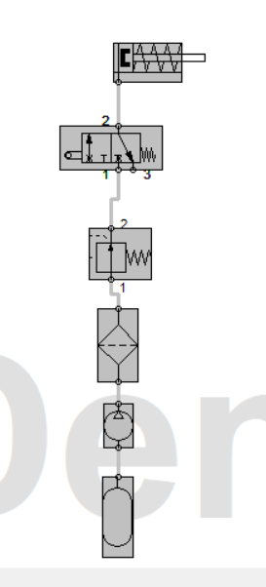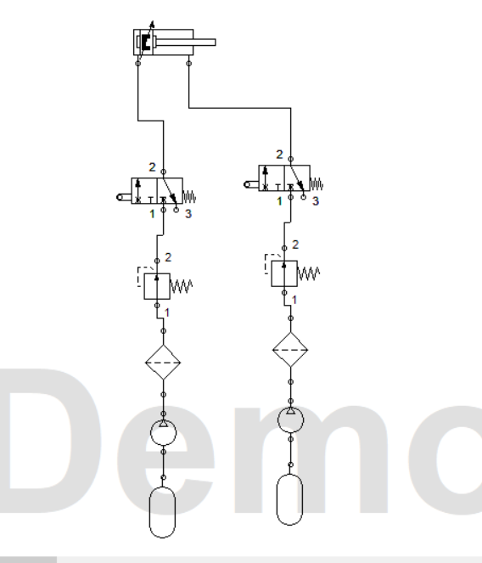

Single acting Cylinder Double acting Cylinder

***Conclusion:***

We learned the basic principle of single and double acting cylinder and their interfacing with push buttons. We also operated the single and double acting cylinder in real life using the hydraulic and pneumatic training bench

**Speed Control of Double Acting Cylinder**

Roll no: 2022-MC-58

**Objective:**

To Control the speed of Double Acting Cylinder, such that the forward moving speed is double of reverse Speed.

**Equipment’s and parts:**

* Double acting cylinder
* 3/2 Pneumatic Valve
* Flow Control Valve
* Connecting Pipes
* Mechanical push button
* Fluid (Air) Reservoir
* Regulator
* Air distributer (Multi diameter pipes Junction)

**Working Explanation:**

The air goes to Flow Control Valve by connecting Pipes, from there it goes to Pneumatic Valve. The output of this Valve is connected to the Push Button which is connected to cylinder for its Reverse Motion. For its forward motion, air from reservoir is connected to Push Button and Supplied to Cylinder.

**Circuit Diagram**

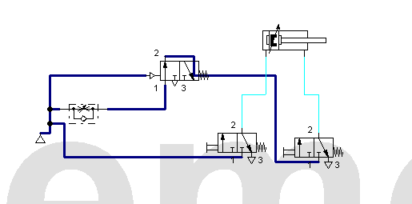

Speed Control of Double Acting Cylinder

**Conclusion:**

We learned the principle of flow control valve and its interfacing with 3/2 Pneumatic Valve. We controlled the speed of double acting cylinder in such a way that its retract speed is half of its extend speed.

**Indirect Control of Single Acting Cylinder**

Roll no: 2022-MC-58

**Objective:**

To Control the Double Acting Cylinder indirectly.

**Equipment’s and parts:**

* Single acting cylinder
* 3/2 Pneumatic Valve
* Connecting Pipes
* Mechanical push button
* Fluid (Air) Reservoir
* Regulator
* Air distributer (Multi diameter pipes Junction)

**Working Explanation:**

The air goes to the input of 3/2 Pneumatic Valve and is the Input of Push Button. The output of Push Button is connected to 3/2 Pneumatic Valve for its initial starting. When Push Button is pushed, the Valve is Activated and air from Supply pneumatically Pushes the single Acting Cylinder, showing the function of Valve.

**Circuit Diagram**

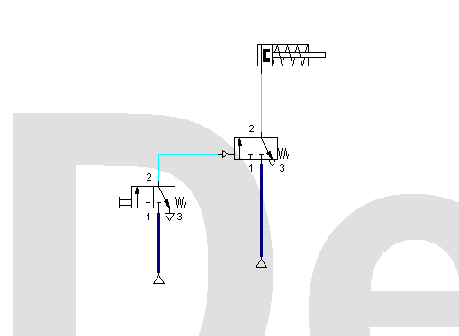

Indirect Control of Single Acting Cylinder

**Conclusion:**

We learned the principle 3/2 Pneumatic valve and its interfacing to drive the single acting cylinder. We indirectly controlled the single acting cylinder to function it through 3/2 valve.

Name: Haseeb_UL_Hassan Roll No:2022_MC_58

Subject: Hydraulics & Pneumatics

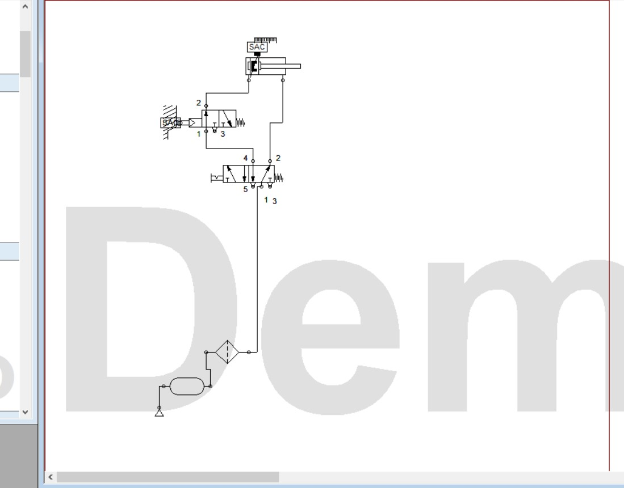

Hydraulics & Pneumatics LAB6

Roll No :2022-MC-58

Task: Use and gate in any application that compromises an actuator, sensor, valves, logical valves with indirect control

Requirements(parts);

1. Pneumatic supply
2. Pressure Regulator
3. Pressure Guage
4. Multiple output single input expansion board
5. Push buttons (3/2 way)
6. And valve
7. Double acting cylinder
8. 5/2 way pneumatically operated valve
9. Roller valve
10. Connecting pipes

Description;

Scenario is, that we will use the and gate to operate double acting cylinder not directly but with help of pneumatically operated 5/2 Way valve so as to avoid the air locking and two push buttons will be used one for moving cylinder to B position and the 2nd valve to lock the old position, when the 2nd valve is pressed it retains position B while in unpressed condition Retains position A

Circuit diagram;

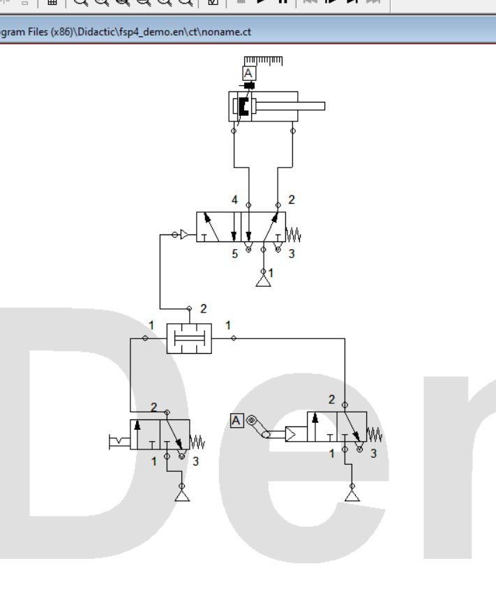

Physical Configuration;

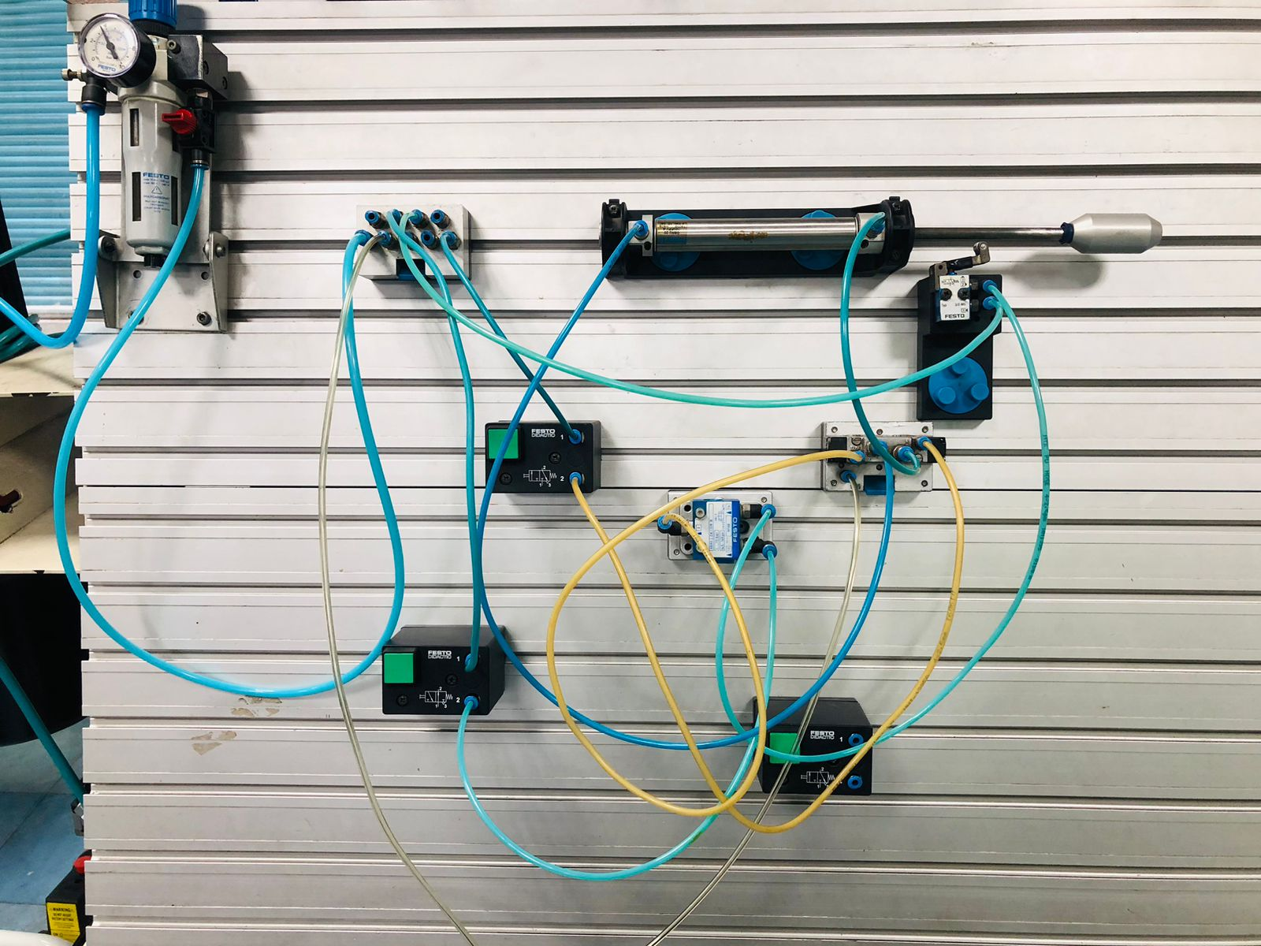

Name: Haseeb ul hassan roll no: 2022_mc_58

Experiement 01:Use of safety valve pneumatic

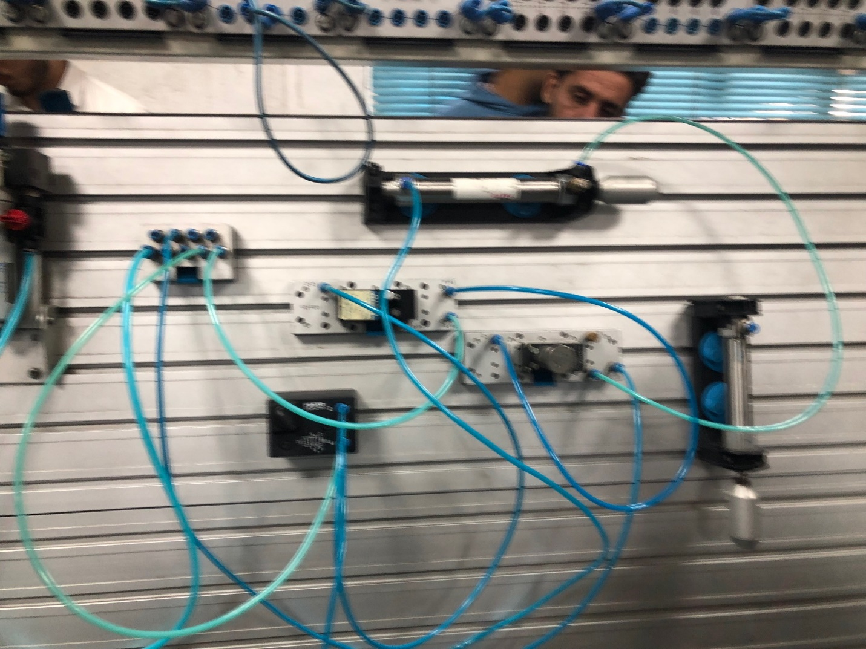

Experiement 2:basic Hydraulic actuator using eletctric switch

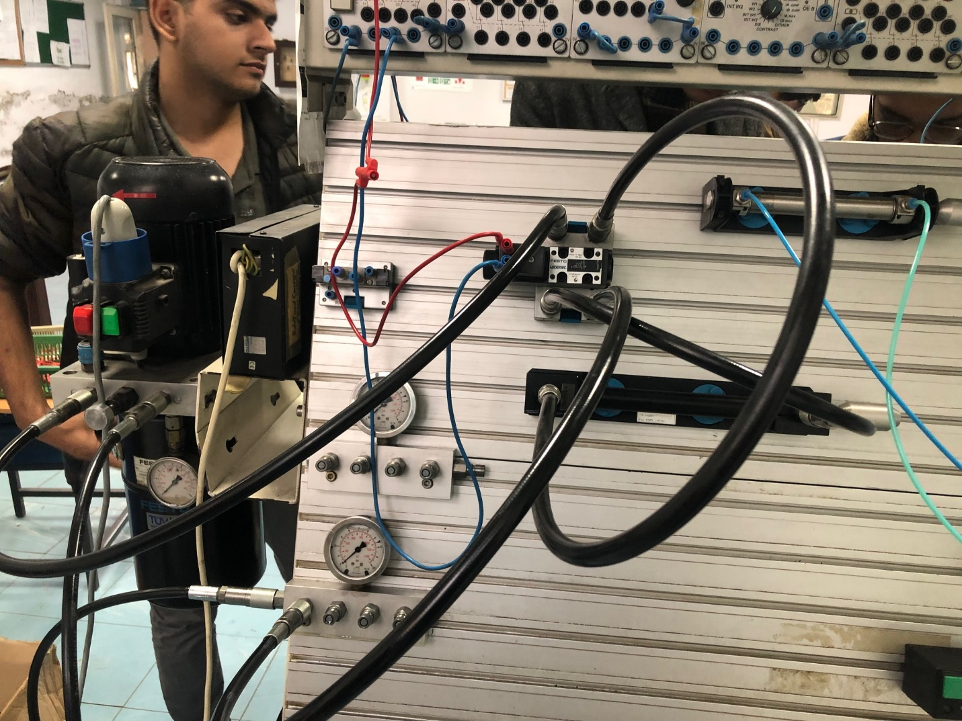

2022_mc_58

Task1:Use electricity to control the position of the dual acting cylinder using electrically operated directional control valve and proximity sensor

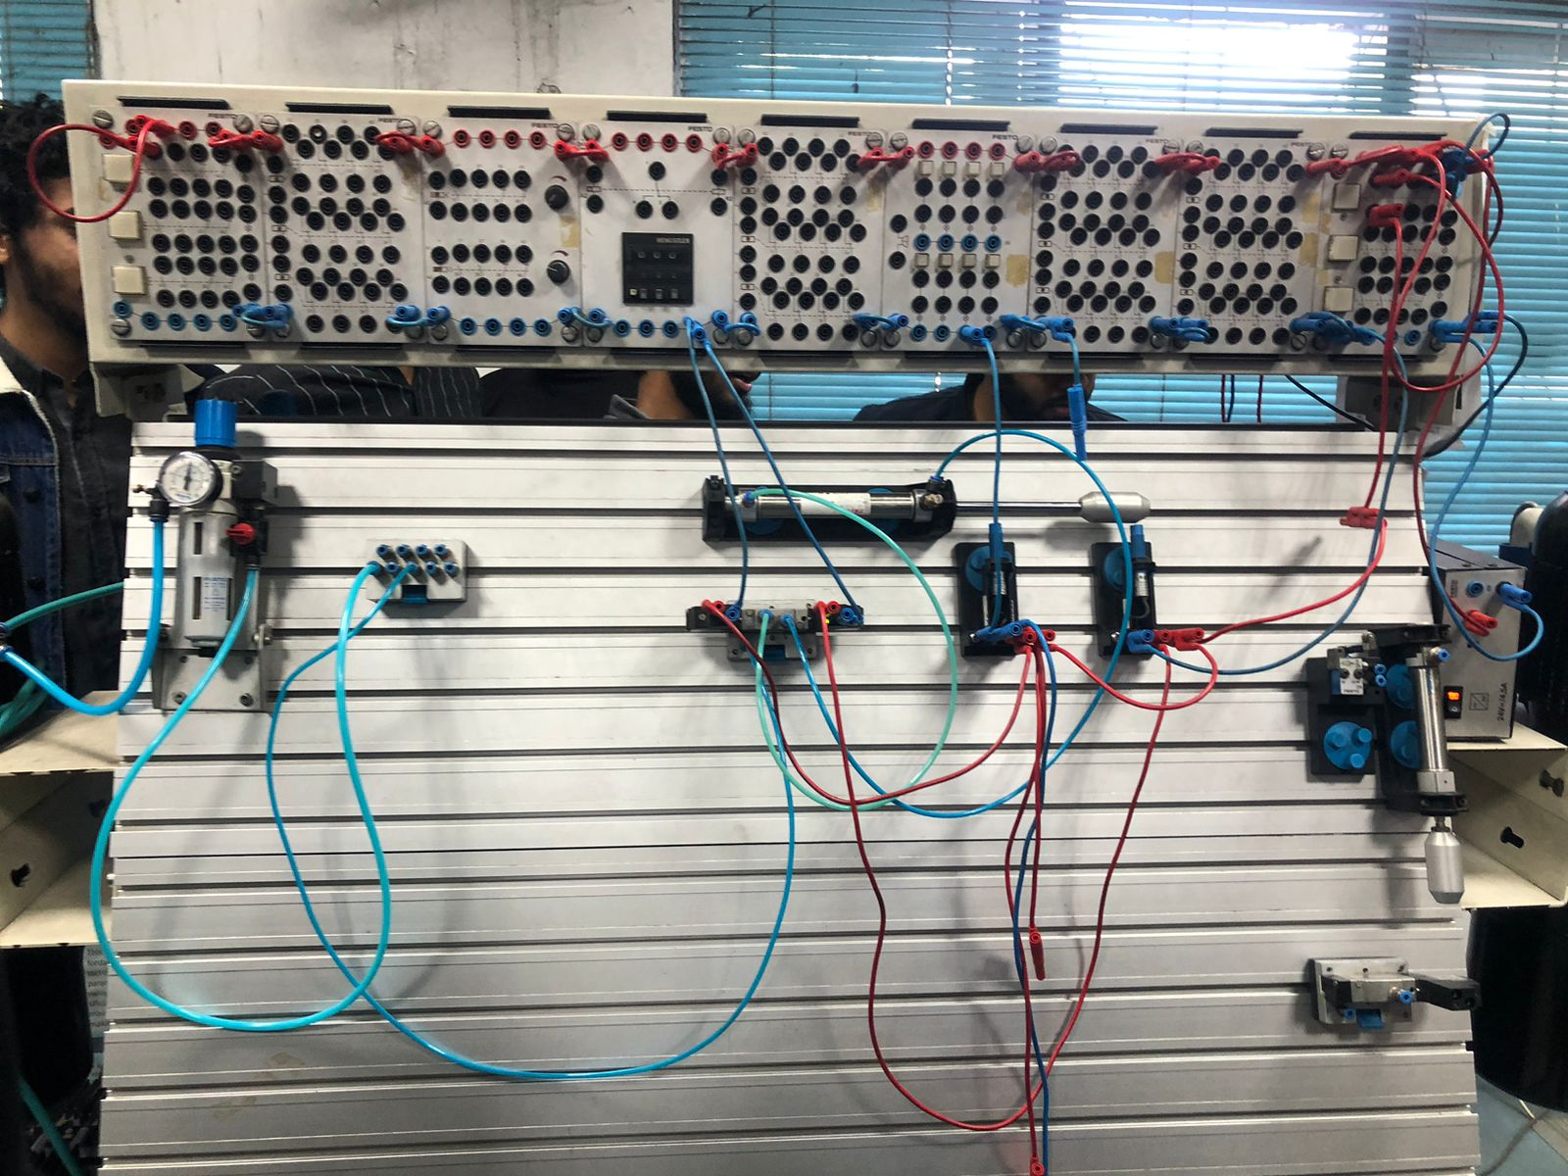

2022_mc_58

Task: use pressure sequence valve to control the operation/cylinder extention_time

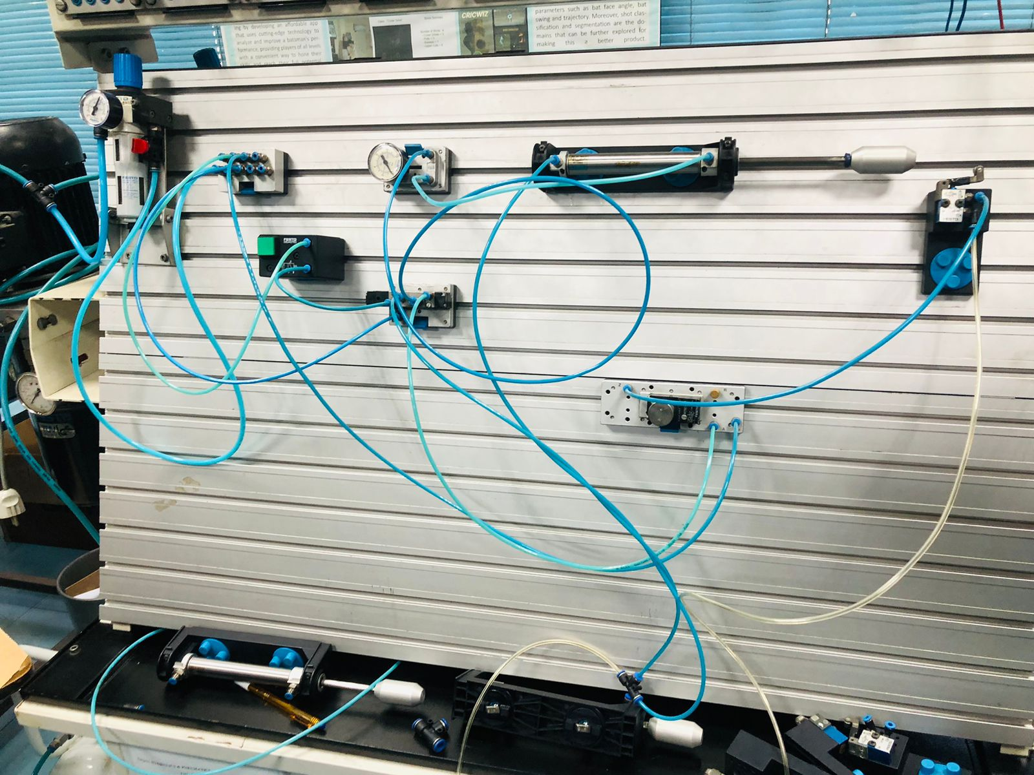

My group mates don’t have the data missing but I have pictures as prof

